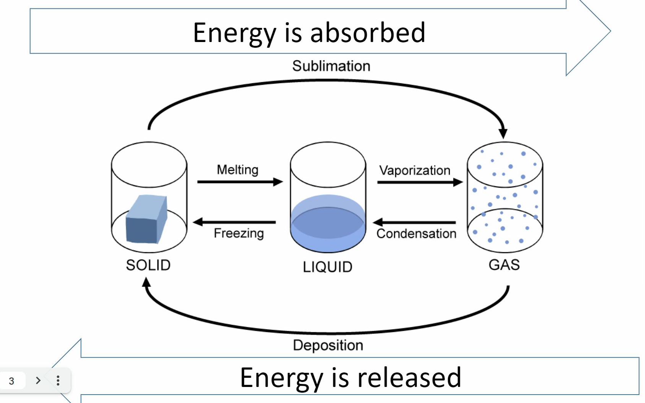
vaporization: liquid to gas
condensation: gas to liquid
melting: solid to liquid
freezing: liquid to solid
sublimation: solid to gas
deposition: gas to solid

Potential energy = stored energy
Kinetic energy = energy of motion
Heat of Fusion - the amount of heat needed to change a solid to a liquid at a constant temperature
Heat of Vaporization - the amount of heat needed to change a liquid to a gas at constant temperature
When you have a phase change, there is no temperature change

Heat of Fusion
- The amount of heat needed to be absorbed to convert a unit of mass of a substance from a solid to a liquid at its melting point
- Formula:
  - is heat of fusion
  - q is energy
  - m is mass
- Heat of fusion for water is 334 joules per gram
- Example: How many Joules are required to melt 255g of ice at 0 degrees Celsius
- Joules in scientific Notation

Vaporization

- Amount of heat needed to be absorbed to convert a unit mass of a substance from its liquid phase to a gas phase

  - is heat of vaporization
  - q is energy
  - m is mass
- Heat of vaporization for water is 2260 Joules per gram
- Example: how many joules of energy are required to vaporize 423g of water at 100 ° C

Practice
- What is the heat of solidification for water?

- How much energy si released into the environment by 50.0 grams of condensing water vapor

- Is melting Endothermic (absorbing heat) or Exothermic (releasing heat)
  - Endothermic, as heating up needs more energy
- Calculate the amount of heat needed to melt 35.0g of Ice at 0°C. Express your answer in Kilojoules

- How many Joules must be added to 10.0g of water to raise it’s temperature from 10°C to 15°C

- 75g of ice at -18°C, change it to steam at 135°C. How much energy is absorbed in the system?

